International Undergraduate
UOG

ADMISSIONS INSTRUCTION
FOR APPLICATIONS



UNIVERSITY OF GUAM
ADMISSIONS & RECORDS OFFICE
303 University Drive
MANGILAO, GUAM 96913

PHONE: (671) 735-2201/2
FAX: (671) 735-2203

E-MAIL: admitme@triton.uog.edu
WEB SITE: www.uog.edu

Please read the following information and review the enclosures before you submit the application and supporting documents.

INTERNATIONAL UNDERGRADUATE ADMISSION INFORMATION AND APPLICATION PROCEDURES

Application and Fee: A completed application must be submitted online or directly to Admissions & Records. All required documents must be submitted to the Admissions Office at the address:
UNIVERSITY OF GUAM
ADMISSIONS & RECORDS OFFICE
303 UNIVERSITY DRIVE
MANGILAO, GUAM 96913

Application fee must be paid at the Cashier’s Office located at the ADMINISTRATION BUILDING from 8:00am – 4:00pm. The NON-REFUNDABLE APPLICATION FEE can be paid online upon submission of your application. Your application fee is valid for one calendar year by semester.

Deadlines: Completed application must be received by the published dates included in this application packet. Applications received after the deadlines for admissions for a particular term will be considered for the next term. Should you decide not to attend the semester you are applying for, you must submit a written request to the Admissions Office to defer your application to the following semester.

Transcripts: First time college applicants are required to have their secondary school or General Educational Development (GED) Institute send a transcript showing completion of twelve years of elementary and secondary education to the Admissions Office. Transfer applicants are required to have their transcripts from all colleges and universities attended sent directly to the Admissions Office at the address above. Foreign college/university transcript(s) are to be evaluated by one of the following U.S evaluation companies: WES, ECE IERF and official course for course evaluation must be sent directly to Admissions Office. Transcripts submitted by the applicant will not be accepted as official. All transcripts become university property and will not be given to or reproduced for the applicant/student.

TOEFL or IELTS Scores: International students are required to have official scores of the Test of English as a Foreign Language (TOEFL) or International English Language Testing System (IELTS) submitted directly to the Office of Admissions and Records at the address above by testing company before applicants can be considered for admission.
The following scores are required for UOG acceptance:
TOEFL: paper-based (500); computer-based (173) internet based test (61) or IELTS: Score of 5.5

Placement Examinations: All entering freshmen and transfer applicants who have not completed at least three (3) semester hours of college-level English composition and at least three (3) semester hours of transferable college-level mathematics course with a grade of “C” or better at an accredited U.S. College or University must take placement examinations in English and Mathematics. Applicants who do not take the English placement test or who do not submit transcript showing completion of college level English can be admitted only as transition students and will be limited in their enrollment to certain approved courses for transition students. Admission under this status is limited to one semester. APPLICATIONS MUST BE PAID AND SUBMITTED TO THE ADMISSIONS OFFICE PRIOR TO PLACEMENT EXAMINATIONS.

Health Requirement: All applicants must supply evidence of having been vaccinated against measles, mumps and rubella (MMR) and the results of a tuberculin skin test taken no earlier than six months prior to the beginning of the entry term. In addition, applicants must complete a personal health survey form and submit it to the Student Health Services Office. Health documents must be submitted to Student Health Office and cleared by the nurse before Orientation and Registration. Failure to submit health documents for your health clearance will delay registration.

Medical Insurance: Must provide proof of valid medical insurance that is valid while on Guam.

Passport and Immigration Documents: Copies of your current passport and any U.S. Immigration and Customs Enforcement (ICE) documents (ie: visa, I-20, I-94, etc) that may have been issued to you.

Financial Support: Financial support form must be certified by the bank or submitted with a bank statement from the sponsor.

*ESTIMATED EXPENSES FOR ONE ACADEMIC SCHOOL YEAR

Academic Year 2018-2019 Undergraduate Graduate

Tuition & Fees $ 12,860.00 $ 12,464.00
Room & Board $ 3,850.00 $ 3,850.00
Transportation (on island) $ 450.00 $ 450.00
Books & Supplies $ 2,050.00 $ 2.250.00
Personal Expenses $ 1,800.00 $ 1,800.00

Total $21,010.00 $20,814.00

*Revised 0711/19

Once the Admissions and Records Office receives all the required documents, an Immigration Form I-20, “Certificate of Eligibility” will be issued. Students should take this document to the U.S. Embassy in their home country where they will receive an F-1 Visa. Students should have the F-1 Visa in their possession prior to entry into Guam.

Discrimination Prohibited: No person in the United States shall, on the ground of race, color, or national origin, be excluded from participation in, be denied the benefits of, or be subjected to discrimination under any program or activity receiving Federal financial assistance, or be treated on the basis of gender, or disability under most education programs or activities receiving Federal Assistance.



APPLICATION CHECKLIST

Prospective international students interested in attending the University of Guam (UOG) should submit the following credentials to the Admissions and Records Office on or before the deadlines listed on the APPLICATION DEADLINES. Notice that the student must meet the deadlines. This is necessary to insure that all requirements for admissions are met.

1. | Fill out and pay application fee of $77
2. | Request for official high school transcript(s) to be sent directly to UOG. All transcripts must be translated to English. Foreign college/university transcript(s) are to be evaluated by one of the following U.S evaluation companies: WES, ECE IERF and official course for course evaluation must be sent directly to Admissions Office.  Educational Credential Evaluators, Inc. https://www.ece.org  International Education Research Foundation, Inc. http://ierf.org  World Education Services, Inc. https://www.wes.org
3. | Submit copy of current passport and visa (only if you are currently under a U.S. visa)
4. | Submit a certified Financial Support Form or attach a sponsors’ latest bank statement.
5. | Request for official TOEFL score from www.ets.org or IELTS from https://www.ielts.org to be sent directly to UOG.
6. | Submit immunization records to Student Health Services. For more information you may call 671-735-2225 or email uogstudenthealth@triton.uog.edu
7. | Provide copy of valid medical insurance that will cover you while you are on Guam. (isoa.org)
8. | Take UOG English and Math placement test

Once the Admissions and Records Office receives all required documents and determine students acceptance, an Immigration Form I-20, “Certificate of Eligibility” will be issued. Students should take this document along with an acceptance letter to the U.S. Embassy in their home country where they will schedule for an F-1 Visa appointment. Students should have the F-1 Visa in their possession prior to entry into Guam.

303 University Drive, Mangilao, Guam 96913
Tel. (671) 735.2201 or 735.2202 Fax. (671) 735.2203 e-mail. admitme@tirton.uog.edu web site. www.uog.edu
A Land Grant Institution accredited by the Western Association of Schools and Colleges
The University of Guam is an equal opportunity employer and provider.

FINANCIAL SUPPORT
The purpose of this form is to assist the Admissions Office in determining that the below named student from abroad (1) will not become a public charge in the event he or she is admitted to Guam (2) does not intend to travel to Guam for the purpose of obtaining permanent resident status (3) does not intend to transfer to another college until completion of studies here. please refer to our current cost of attendance listed on “instructions to applicant”.
Student:

Name of Student: _____________________________ Date of Birth: _________________ E-mail address: __________________
Family First Middle

Permanent address in home country: ____________________________________________________________________________________________
If you plan to bring dependents, please list their names and birthdates in the space below. Provide evidence that approximately $4,000 per year/per dependent is available above the amount required for you:
Name SEVIS I.D.# Birth date Country of Birth Country of Citizenship Relationship Gender
_______
_______
_______
Sponsor:

Name of Sponsor: ________________________________________________________ Phone: _____________________________________

Address: ________________________________________________________________________________________________________________________

Relationship to Student: ________________________________________ Yearly amount of support in $ _______________________________
If you expect to receive a grant/loan, please provide the name and address of the sponsoring agency and attach a copy of your award letter:
__________________________________________________________________________________________________________________________________
Please read the following statements before signing.
I guarantee, without reservation, the maintenance, welfare, and all expenses including tuition, incidental expenses, requisite travel, insurance, and medical expenses incurred by the student while in Guam and enrolled at the University of Guam. I also guarantee that I can pay the cost of transportation and incidental expenses from the student’s resident country to Guam and back upon completion of studies. If guarantee includes payment of travel expenses, please complete this paragraph: That I can pay the cost of transportation and incidental expenses from to Guam and from Guam to upon completion of studies at the University of Guam. If any information changes, I will immediately notify the Office of Admissions and Records.

Signature of sponsor: ____________________________________________________ Date:___________________________________

Bank Verification for Visa Purposes:

I certify that the above named sponsor has the amount of $_____________ on deposit with our institution sufficient to provide financial support for (indicate name of student):
_________________________________________________________________________
This certification is offered with no responsibility on the part of this bank or financial agency.

For Foreign Banks outside the U.S.: This bank certifies that there will be no restrictions for the transfer of funds in the event that it is needed.
No Restrictions Yes, please specify: _______________________________________
Bank Seal or Stamp
Name of bank (or agency):_______________________ Country: _____________________

Address: ___________________________________________________________________________
Name of account holder:
Type of account: savings certificate of deposit other ___
Date account opened: Month _______________ Day ____________ Year _____________
Confirmed by bank employee:
Name: ______________________________________________________Title: _________________

Signature: _________________________________________________ Date: ________________

303 University Drive, Mangilao, Guam 96913
Tel. (671) 735.2201 or 735.2202 Fax. (671) 735.2203 e-mail. admitme@triton.uog.edu web site. www.uog.edu
A Land Grant Institution accredited by the Western Association of Schools and Colleges
The University of Guam is an equal opportunity employer and provider.

IMPORTANT: A non-refundable Application Fee must accompany this application. Certified Cashiers check or money order should be made payable to the University of Guam. Please use a pen (print in ink) or a typewriter in filling out this form and submit the completed application to the Admissions Office.



University of Guam
Application for Admission
International undergraduate Students

LEGAL NAME: Last, first middle |  |  |  |  |  |  |  |  | any other name used on other required documents
PERMANENT foreign ADDRESS: (from country of citizenship)

MAILING ADDRESS ON GUAM (Effective Date):

CONTACT INFORMATION: home: work: cell: email:
indicate the term and year in which you wish to enroll:
Note: Should you decide not to attend the semester you are applying for, you must submit a written request to the Admissions Office to defer your application to the following semester to avoid paying another application fee.
- fall 20________ |  |  | - spring 20________ |  |  |  |  |  |  |  |  | - summer 20_______
enrollment status:  (Check one) | - new Freshman  - 2nd Bachelor’s (UOG graduate) |  |  |  |  | - New Non-Degree  - 2nd BA graduate (other College) |  |  |  |  |  |  |  | - INTERNATIONAL EXCHANGE  - New Transfer
educational goal:  (Check one) | - To provide a foundation for my career objective  - Bachelors degree from UOG  - Transfer credits to another institution |  |  |  |  | - To complete a Second Baccalaureate Degree  - Undecided  - Other (specify) ____________________________
what major program of study do you intend to pursue? (all international students are required to declare a major in order to be considered for acceptance to UOG).
Note: Some majors, such as, but not limited to, Education, Nursing, Social Work, have additional admissions requirements before being accepted, please consult the catalog for detail(s) in their program.

PERSONAL DATA
date of birth: Month Day Year  -------------/--------------/------------ |  |  |  |  |  |  |  |  |  | place of birth: (country)
US. social security no:  -----------/-----------/----------- |  |  |  |  |  |  |  |  |  | first language:
tax payer identification no:
-----------/-----------/-----------
gender: ( ) Female ( ) Male |  |  |  |  | maritial status: ( ) Single ( ) Married ( ) Divorced ( ) Widowed
ethnicity :  (Check one) |  | - IN–American Indian/Alaskan Native  - BN-Black Non-Hispanic  - WN–Caucasian (White) Non Hispanic  - HP – Hispanic |  |  |  | - AC – Asian – Chinese  - AF – Asian – Filipino  - AN – Asian – Indian  - AJ – Asian – Japanese |  |  |  |  |  |  | - AK – Asian – Korean  - AV – Asian Vietnamese  - PO – Pacific – Other  - OT Other:___________________
parent, guardian, spouse, or person to contact in case of emergency:
full name: relationship:
mailing address:
home phone: |  |  |  | work phone: |  |  |  |  |  |  | cell:
date of birth: |  |  |  |  |  |  |  | email:

EDUCATIONAL DATA
indicate the number of years you ATTENDED EACH of the following:
Elementary School _______________________  Junior High /Middle School__________________ |  |  |  |  |  |  | Senior High School _________________________  College/ University _________________________

An applicant who has successfully completed twelve (12) years of formal education or who has passed the General Educational Development (GED) Test with a cumulative score of 45 or higher will be considered for admission. Foreign transcript records must be translated into English. We will not accept transcripts submitted by students; academic records must be mailed directly to the Admissions & Records Office from the issuing institutions.

HIGH SCHOOL(S) ATTENDED
name and location (please print full name & location) |  | dates attended |  | date graduated
 |  | to
 |  | to
GENERAL EDUCATION DEVELOPMENT (G.E.D., if applicable)
name and location (please print full name & location)

UNIVERSITY/COLLEGE(S) ATTENDED
name and location (please print full name & location) | dates attended |  | majors |  | degree & date (m/yy) earned
 | to
 | to
 | to
 | to

Are you in good academic standing at all previous institutions attended and eligible to return? Yes ( ) No ( )

Failure to list all institutions previously attended may result in cancellation of your admission. Your application will not be considered complete until we have received official transcripts of all previous academic work sent directly from your previous colleges and universities to the Office of Undergraduate Admissions. If your cumulative GPA at the last institution attended is below the required minimum of 2.00, please submit a written request to the Registrar for consideration of probational admittance to the University of Guam.

If you have ever been on PROBATION or SUSPENDED or DISMISSED by another institution, give the type and date of action taken and indicate your present status.
institution | type | date | present status

RELEASE OF ALL RIGHTS IN PHOTOGRAPH
I authorize the University of Guam and those acting under its authority, to use for any lawful purposes whatsoever, photographic portraits or pictures of myself, or in which I may be included in whole or in part, or composite of distorted in character, or form, in conjunction with my own name, or reproductions thereof in color or otherwise, made through my medium.

_____________________________________________ ___________________________________
Signature Date

PASSPORT AND VISA INFORMATION
citizenship of:_________________________________________________________________
(Indicate country)

- a. Passport expiration date: | c. Type of VISA? | VISA Number: | e. Date TOEFL was taken | TOEFL Score
- b. What country do you reside in ? | - d. I – 94 Number |  | f. Date IELTS was taken | IELTS Score
I certify that the statements I have made in this application are true and correct. I understand that any false information found to have been willfully given by me herein or in any supporting documents should be cause for denial of this petition.

______________________________________________ __________________________________
student’s signature date

Nonimmigrant aliens, e.g., B, F, H, and E visa holders, are classified as non-residents and are not qualified for resident tuition rates or exemptions.

DO YOU HAVE A PHYSICAL OR LEARNING DISABILITY? (for statistical reporting only) Yes ( ) No ( ) If you are a person with a disability and need of assistance, please call the ADA Office at (671) 735-2971, (Voice) TTY. For support services and information. Please call at least 72 hours or three days in advance.

Release of Information
The University of Guam complies with the statutes and regulations of the Family Educational Rights and Privacy Act of 1974 pertaining to the confidentiality of a student’s personal and academic records in its possession.

The University of Guam is authorized under the provisions of the Family Educational Rights and Privacy Act of 1974 to release public directory information, concerning students. Directory information includes the student’s name, address, email address, telephone listing, date and place of birth, major field of study, class schedule, participation in officially recognized activities and sport, weight and height of members of athletic teams, dates of attendance, degrees and awards received, and the most recent previous educational agency or institution attended by the student. The above-designated information is subject to release by the University of Guam at any time unless it has received prior written objections from the student specifying information, which the student requests not to be released.

Students wishing to restrict release of directory information must file a “Request to Prevent Disclosure of Directory Information” form at the Office of Admissions and Records. This form must be filed within two weeks after the first day of instruction of the regular semester and within one week after the first day of instruction of the summer session. The notification to prevent disclosure of directory information is effective only for the one term from which the student is registered.

== Optional ==
I authorize the following individual(s) full access to my student record, to include but not limited to, transcript requests, grades, enrollment certification, and registration. I understand that I may cancel this authorization at anytime.

Name (Please print) Relationship Date of birth
I certify that the statements I have made in this application are true and correct. I understand that any false information found to have been willfully given by me herein or in any supporting document should be cause for rejection of my application or for my immediate dismissal.

________________________________________ _________________________________________
STUDENT’S SIGNATURE DATE

The following information is needed before your application status to the University of Guam can be determined:

_____Official High School Transcript Indicating Graduation Date | _____Student Health Clearance (Shot Records)
_____Official Documentation of GED Scores | _____Financial Support documents
_____TOEFL or IELTS Scores | _____Proof of Health Insurance with Valid Coverage on Guam
_____Official Statement of Standing (If transfer non-degree student) | _____Copy of passport
_____Official College Transcript(s) | _____Other

I understand that I need to submit the document(s) indicated above in order to complete my application. This may delay my acceptance to the university or registration for my classes.

_________________________________________________ ___________________________________________________________

Student (Print) Student’s signature

____________________________________________________ ___________________________ __________________________

date A&R Technician date

DO NOT WRITE ON THIS SPACE

RECRUITMENT EVENT:
- High School  - Website  - Walk-In | - Recruitment Event (Off-Campus)  - Recruitment Event (On-Campus)  - Other (Specify):

APPLICATION RECEIVED ON__________________________________ BY_____________________________________________
Date Receiving Person

ADMISSION STATUS: ( ) Regular Student ( ) High School Student ( ) Special Student ( ) Application Rejected ____________________
Reason

APPLICATION FEE RECEIVED_________________________ RECEIPT NO. ____________________ ( ) LATE


The deadline dates for prospective students, as well as tuition costs, are provided below.
SCHEDULE OF APPLICATION DEADLINES TUITION COST AND APPLICATION FEES

INTERNATIONAL (I-20) FOREIGN UNDERGRADUATE & GRADUATE APPLICANTS Tuition (Per Credit)
Entry Term | Application Deadline | Application Fee | Undergraduate /Graduate
Summer 2019 | February 4, 2019 | $77.00 | $504.00 $650.00
Fall 2019 | March 13, 2019 | $77.00 | $504.00 $650.00
Spring 2020 | September 3, 2019 | $77.00 | $504.00 $650.00

RESIDENT/NON-RESIDENT UNDERGRADUATE AND GRADUATE APPLICANTS
Tuition (Per Credit)
Resident Non-Resident
Entry Term | Application Deadline | Application Fee | Undergraduate/Graduate | Undergraduate/Graduate
Summer 2019 | April 12, 2019 | $52.00 | $210.00 $285.00 | $504.00 $650.00
Fall 2019 | May 30, 2019 | $52.00 | $210.00 $285.00 | $504.00 $650.00
Spring 2020 | November 15, 2019 | $52.00 | $210.00 $285.00 | $504.00 $650.00

Application fee and tuition fee are subject to change. Semester fees also apply.
PLACEMENT EXAMINATION DATES
(Picture ID Required)
PROSPECTIVE APPLICANTS MUST SUBMIT AND ADMISSIONS APPLICATION FORM
BEFORE TAKING THE PLACEMENT EXAMINATIONS

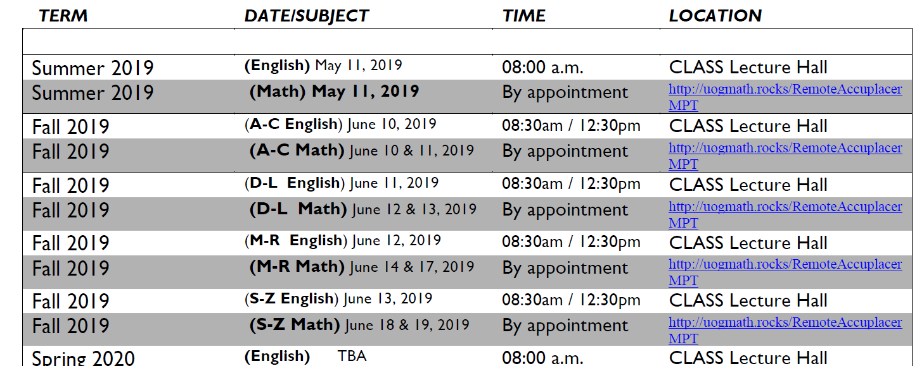

Please be advised that the placement test dates are subject to change. A reminder will be sent to the student via email the week of the test date.
For more information contact:
English Dept. Tel. 735-2725-6 or Fax 734-0012
Math Dept. Tel. 735-2825 or Fax 734-4582

UNIVERSITY OF GUAM
UNIBETSEDAT GUAHAN
ENROLLMENT MANAGEMENT & STUDENT SERVICES
OFFICE OF ADMISSIONS AND RECORDS
UOG Station, Mangilao, Guam 96923
Phone: (671) 735-2201-2 Fax: (671) 735-2203
e-mail: admitme@triton.uog.edu website: www.uog.edu

REQUEST FOR TRANSCRIPT: HIGH SCHOOL/COLLEGE/UNIVERSITY

It is the applicant’s responsibility to mail this form to the appropriate high school, college or university previously attended. We will not accept transcripts submitted by students; academic records must be mailed directly to the Admissions and Records Office from the issuing institution.

TO THE REGISTRAR/RECORDS CLERK:
______________________________________________________
COMPLETE NAME OF HIGH SCHOOL/COLLEGE/UNIVERSITY

____________________________________________________________
STREET ADDRESS

____________________________________________________________
CITY STATE ZIP CODE

Please Send: _____High School record (showing date of graduation or withdrawal)
_____College/University transcript

NAME (Type or print last name first) | DATE OF BIRTH
MAIDEN NAME (If applicable) | PLACE OF BIRTH
MAILING ADDRESS | LAST TERM ATTENDED (Year)
SOCIAL SECURITY NO. | DATE OF GRADUATION (If applicable)

Student’s Signature: _____________________________________________ Date: __________________________
- - - - - - - - - - - - - - - - - - - - - - - - - - - - - - - - - - - - - - - - - - - - - - -
(PLEASE DETACH AND RETURN TO THE UNIVERSITY OF GUAM)

TO THE REGISTRAR, UNIVERSITY OF GUAM

SUBJECT: TRANSCRIPT REQUEST OF: ______________________________________
NAME OF STUDENT

_____The transcript of the above named student is enclosed.

_____There is no record of the above named student at this college or university.

_____The transcript of the above named student cannot be released for the following reasons(s):

__________________________________________________________________________________

__________________________________________________________________________________

__________________________________________________ ______________________________________________ SIGNATURE SCHOOL/COLLEGE/UNIVERSITY



Thank you for your interest in the University of Guam.
Your Natural Choice
To Enlighten
To Discover
To Serve

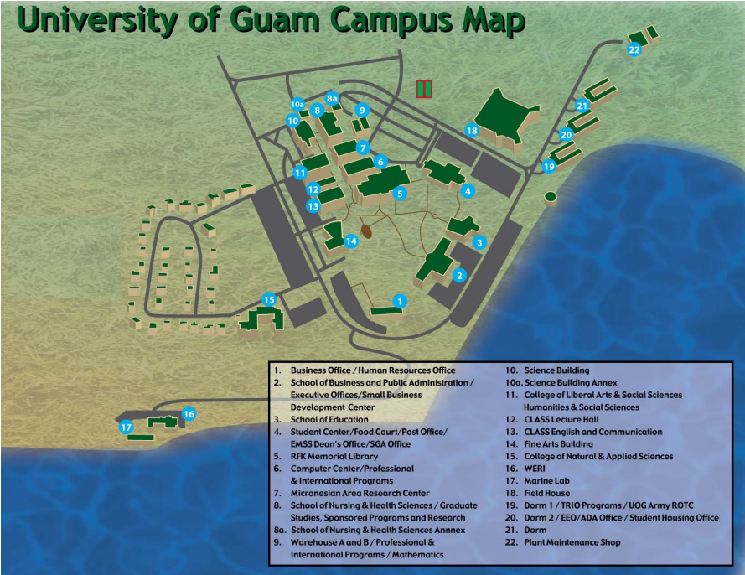


UOG CAMPUS CONTACT

UOG Residence Hall 671-735-2260/61
Student Health Service 671-735-2225
Student Counselors 671-735-2271/3342
Student Life Office 671-735-0246
Campus Security 671-735-2365
Security Guard on Duty 671-888-2456

GUAM EMERGENCY CONTACT
Emergency 911
Guam Police Department 671-472-8911
Guam Mangilao Fire Department 671-734-2264

