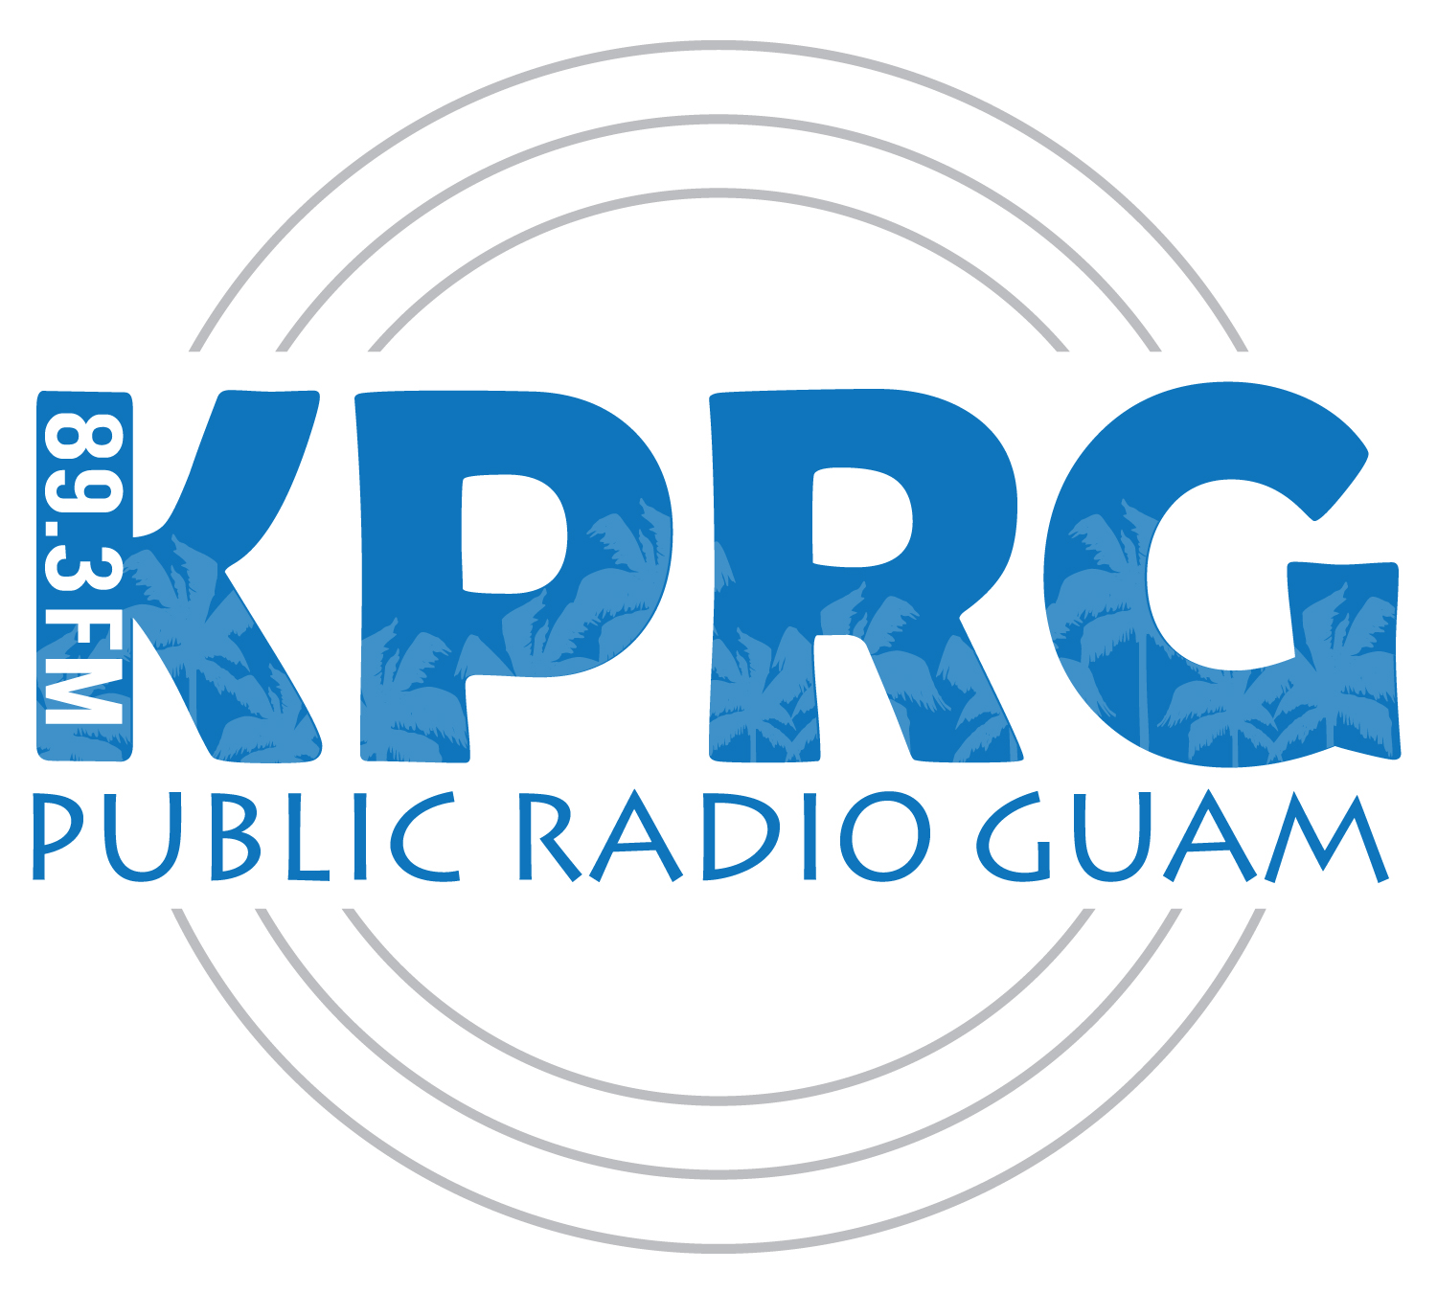

Program Annual Report:

KPRG Mission Statement:

KPRG-FM 89.3 is the public radio broadcast station of the Guam Educational Radio Foundation. KPRG is licensed by the Federal Communications Commission to serve the public interest, convenience and necessity of the people on the island of Guam. KPRG is a high-quality news, information and entertainment service in a non-commercial environment. KPRG is a non-advocating entity with an obligation to give fair and impartial treatment to all sides of issues.
KPRG acquires produces and broadcasts programs carefully selected to fulfill the station's obligation to both the Federal Communication Commission and the Guam Educational Radio Foundation. KPRG's programming is designed to enrich the artistic and cultural life within its coverage area; it pioneers new concepts and techniques; it serves minority as well as majority needs and interests; it enhances the quality and texture of life on Guam.
KPRG assists the University of Guam in the achievement of its paramount objective to serve the educational and intellectual needs of the students, faculty and staff of the University as well as the residents of Guam. Furthermore, as a public service vehicle, KPRG-FM assists the University of Guam's endeavor to reach out and make itself available to the people.

Current Goals and Objectives:
- Financial Solvency and Independence.

  - Business Underwriting: We must increase the level of business underwriting in a manner consistent with KPRG’s non-commercial nature.

  - Financial Management and Reporting: Is currently debt free. Management must set and adhere to specific targets and benchmarks, and timely inform the Board of financial progress and setbacks.

- Market Development and Improving Awareness of KPRG.

  - KPRG needs to reach beyond its established audience to attract new groups of listeners not necessarily familiar with public radio. Of course, this needs to be done consistently with our mission and without alienating our existing core audience.

- Member Relations, Participation and Feedback.

  - Membership is a valuable resource which should be tapped to help foster KPRG’s continued existence and growth. Keeping members happy requires careful attention to member needs. It should be a top management priority.

    - What can be done to attract more members?

- Technical Issues and Facilities.

  - Explore technical options for live-remote and phone-patch broadcasts.

- Program Quality Issues/Community Outreach.

  - KPRG must maintain its commitment to public service and community programming.

- Volunteer Development and Appreciation.

  - Volunteers are the backbone of public radio. Appropriate measures should be taken to recruit, retain and reward volunteers for on as well as off-air endeavors.

  - We need to maintain a volunteer coordinator.

- Personnel Development.

  - Develop staff pattern consistent with organizational needs and grant requirements.

Program Accomplishments (related to Goals above)

- Debt remains at 0
- KPRG has improved it’s outreach to the community by doing awareness programs around the island and numerous youth, non-profit organizations and social groups
- KPRG completed a member survey in June 2016 and is in the process of analyzing the results.
- KPRG will broadcast at full strength sometime
- KPRG has maintained a high level of local and national programming
- KPRG just held a volunteer party to celebrate the success of the Summer 2016 fund drive.
- KPRG is presently fully staffed and trained.

KPRG Source of Revenue:
KPRG receives Revenue from four primary sources a appropriation from the Government of Guam, a yearly grant from the Corporation for Public Broadcasting, Membership (community) Pledges, and business underwriting.

KPRG Number of Employees:
Currently KPRG has 3 full time employees and 1 part-time employee.
Chris Hartig – General Manager
Ryan Luzanta – Assistant General Manager
Robert Wang – Production Director
Tomas Maxedon III – News Director

Contracts:
National Public Radio $33,360, 12 month contract, Programming
Public Radio International $9,456 12 month contract, Programming
American Public Media $7996 12 month contract, Programming
All programming contracts coincide with our fiscal year running from Oct 1, 2015 to Sept 30, 2016

MS075005.RTT

